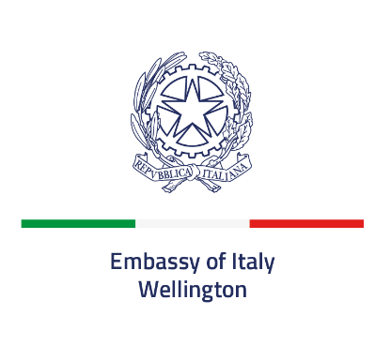

Sponsorship Contract for
Italian Cultural Event ……………………

GIVEN the public notice published on the website of the Embassy of Italy in Wellington regarding the search of sponsors for Cultural Events in 2026;

GIVEN the offer, received on .... …........... by the company .........................................................;

GIVEN the compliance of this offer with the aforementioned public notice and the fairness of the commitment the Sponsor has undertaken to bear, as well as the suitability and reliability of the Company / Firm itself;

The Italian Embassy in Wellington (hereinafter Sponsee), represented by Ambassador Cristiano Maggipinto
and
the Company ............................. (hereinafter Sponsor), represented by Mr./Ms. ........................., acting as ....................................,

the Parties, mutually acknowledging that the above premises are an integral part of this agreement

agree upon and stipulate the following:

ART. 1
OBJECT OF THE CONTRACT
This contract relates to the collaboration relationship, in the form of technical sponsorship, between the Embassy of Italy in Wellington and the Company .........................., which is given the title of Sponsor of the cultural Event…………………………..

ART. 2
BINDING CLAUSES
All the contents of the above-mentioned public notice published on the website of the Embassy of Italy in Wellington concerning the search of sponsors constitute binding clauses of this contract.

ART. 3
OBLIGATIONS OF THE SPONSOR
The Sponsor undertakes to provide the following:
____________________________________________________________________________________________________________________________________________________________________________________________________________________________________________________________________________________________________________in favor of the Embassy of Italy in Wellington within 10 days from the date of signing this contract and no later than two days prior to the Event;

ART. 4
OBLIGATIONS OF THE SPONSEE
The Sponsee undertakes to promote the brand, image and activities of the Sponsor in the context of the activities planned for each event, in accordance with the procedures indicated in the aforementioned public notice concerning the search of sponsors.

ART. 5
DURATION OF THE CONTRACT
This contract is effective from the date of the signing of both parties until the respective commitments have been executed.

ART. 6
TERMINATION OF THE CONTRACT
This contract will be terminated:
a) if the Sponsor is in default in relation to the respective contractual obligations;
b) if conflicts of interest arise between the activity of the Embassy of Italy in Wellington and that of the Sponsor, without prejudice to:
1. the attempt to resolve the conflict to safeguard the public interest;
2. the rights accrued by the parties at the time of termination of the contract;
c) if acts and/or facts are put in place, even indirectly, damaging the image, activities and the right of confidentiality of each party.

ART. 7
WITHDRAWAL FROM THE CONTRACT
The Sponsee has the right to withdraw from this contract at any time for reasons of public interest and /or for reasons of foreign policy, upon simple request, without conditions or limitations of any kind, free of charge and without prejudice to the right to the return of advances of price paid previously and exceeding the consideration for services already rendered and delivered.

ART. 8
TREATMENT OF PERSONAL DATA
Pursuant to and for the purposes of art. 13 of Regulation (EU) 2016/679, the personal data provided by the Sponsor mandatory for the purposes related to the stipulation and management of this contract, will be processed by the Embassy of Italy in Wellington, in compliance with the provisions contained in the same legislation.

ART.9.
DISPUTES
Any disputes relating to this contract or in any case also indirectly attributable to it, will be settled amicably. Otherwise, the competent court is that of Rome.

ART. 10
REFERENCE
For any matter not provided for in this contract, reference is made to the laws, regulations and regulatory provisions in force.

Wellington, ……………..2026

For the Company The Ambassador

................................................. Cristiano Maggipinto

.................................................

(name, surname and position of signatory)

